Filter Method:

Advantages:

* Bandwidth Efficiency: The filter method efficiently uses the available bandwidth by transmitting only one sideband along with the carrier.
* Reduced Adjacent Channel Interference: Since only one sideband is transmitted, the potential for adjacent channel interference is reduced compared to double-sideband modulation.
* Power Efficiency: It is more power-efficient than DSB-FC modulation since it does not transmit the redundant carrier.

Limitations:

* Complexity: Implementing the filter method requires precise filters to suppress one sideband effectively, which can add complexity to both the transmitter and receiver.
* Frequency Selectivity: The filter method requires careful tuning and adjustment of the filters to maintain signal integrity, especially in the presence of frequency drift or variations.

Phasing Method:

Advantages:

* Bandwidth Efficiency: Similar to the filter method, the phasing method also achieves bandwidth efficiency by transmitting only one sideband.
* Reduced Complexity: The phasing method can be implemented with simpler circuitry compared to the filter method, making it more practical in some applications.

Limitations :

* Frequency and Phase Alignment: Proper frequency and phase alignment between the modulating signal and the carrier are critical for successful demodulation, which can be challenging to achieve in some scenarios.
* Sensitive to Phase Imbalance: Any phase imbalance or error in the modulation process can degrade signal quality and introduce distortion.
* Complex Demodulation: Demodulation in the phasing method typically requires coherent detection, which can add complexity to the receiver design.

Third Method (commonly refers to the Weaver's or Hilbert transform method):

Advantages:

* Simple Implementation: The third method offers a relatively simple implementation compared to traditional filter or phasing methods.
* Reduced Complexity: It simplifies the process of generating SSB signals by using a Hilbert transform or a Weaver modulator, reducing the need for complex filters or mixers.
* Improved Signal Quality: By maintaining better frequency and phase relationships, the third method can often yield improved signal quality.

Limitations:

* Sensitivity to Timing and Phase Errors: Like other SSB generation methods, the third method is sensitive to timing and phase errors, which can degrade signal quality if not properly compensated for.
* VSB Modulation Applications

The applications of VSB modulation include the following.

- VSB modulation is standard for the transmission of TV signals. Because the video signals require a large transmission BW using the techniques like DSB-FC otherwise DSF-SC.

- This is a type amplitude modulation that is mainly used for the TV broadcast worldwide. In this broadcast, it is essential to broadcast the information of video and audio concurrently.

- In the transmission of VSB, the higher sideband of video signal & picture carrier are broadcasted without any control. Where a vestige is a fraction of lower sideband and it is transmitted & the residual part is covered up

- When the usage of BW is considered, then this is the most suitable and proficient technique.

|  |  |  |
| --- | --- | --- |
| Feature | TRF Receiver | Superheterodyne Receiver |
| **Working Principle** | Amplifies and demodulates the signal at its original frequency | Converts the signal to a fixed intermediate frequency (IF) before amplification and demodulation |
| **Complexity** | Simpler design | More complex design with multiple stages |
| **Selectivity** | Poor selectivity, especially at higher frequencies | High selectivity due to fixed IF filtering |
| **Sensitivity** | Lower sensitivity | Higher sensitivity due to cascaded amplification stages |
| **Image Frequency** | No image frequency problem | Image frequency problem exists, requiring additional filtering |
| **Fidelity** | Lower fidelity due to limited selectivity | Higher fidelity due to better selectivity and amplification |
| **Applications** | Simple AM radios, crystal sets (historical) | Most modern radio and communication systems |

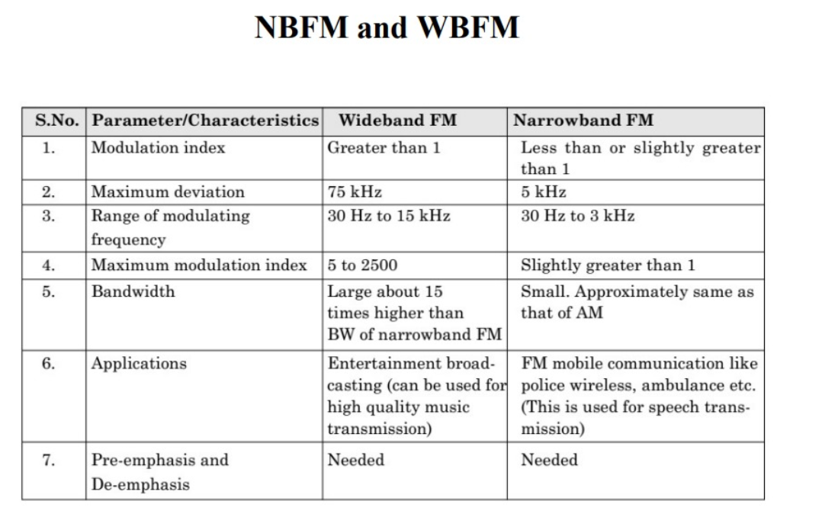

**Low Level vs High Level Modulation**

|  |  |  |
| --- | --- | --- |
| Aspect | Low-Level Modulation | High-Level Modulation |
| Definition | Modulation of the carrier wave by directly varying its amplitude, frequency, or phase. | Modulation of the carrier wave by varying parameters such as pulse width, pulse position, or pulse code. |
| Complexity | Typically involves simpler modulation techniques like Amplitude Modulation (AM), Frequency Modulation (FM), or Phase Modulation (PM). | Involves more complex modulation techniques such as Pulse Width Modulation (PWM), Pulse Position Modulation (PPM), or Pulse Code Modulation (PCM). |
| Efficiency | Less efficient in terms of bandwidth and power usage compared to high-level modulation. | Generally more efficient in terms of bandwidth and power usage due to optimized modulation techniques. |
| Applications | Commonly used in traditional analog communication systems like AM/FM radio broadcasting. | Frequently employed in digital communication systems, digital audio systems, and data transmission applications. |
| Signal Quality | Susceptible to noise and interference, which can degrade signal quality. | Often provides better signal quality and resistance to noise due to the digital nature of modulation. |
| Implementation | Requires simpler hardware and circuitry for modulation and demodulation. | Often requires more sophisticated hardware and processing algorithms for modulation and demodulation. |
| Bit Rate | Typically lower bit rates compared to high-level modulation techniques. | Generally capable of higher bit rates, making it suitable for digital data transmission. |
| Compatibility | Less compatible with digital systems and modern digital communication standards. | More compatible with digital systems and widely used in digital communication standards. |
| Examples | AM (Amplitude Modulation), FM (Frequency Modulation), PM (Phase Modulation). | PWM (Pulse Width Modulation), PPM (Pulse Position Modulation), PCM (Pulse Code Modulation). |

* **Limitations of DSB-FC**
* DSB-FC (Double Sideband Full Carrier) modulation, while a simple and commonly used modulation technique, has several limitations:
* **Bandwidth inefficiency:** DSB-FC modulation utilizes twice the bandwidth of the original message signal. This inefficiency can be a significant limitation, especially in scenarios where bandwidth is limited or expensive.
* **High power consumption:** Transmitting both sidebands along with the carrier requires more power compared to other modulation techniques like SSB (Single Sideband) or AM (Amplitude Modulation) with suppressed carrier. This can be a limitation in applications where power consumption needs to be minimized.
* **Susceptibility to channel distortion:** DSB-FC modulation is susceptible to channel distortion and noise. Any distortion in the channel can affect both sidebands and the carrier, potentially leading to degraded signal quality and increased error rates.
* **Complexity of demodulation:** Demodulating DSB-FC signals requires more complex circuitry compared to other modulation techniques. Recovering the original message signal from the modulated waveform involves coherent detection and carrier recovery, which adds complexity and cost to the receiver design.
* **Interference with adjacent channels:** DSB-FC modulation can cause interference with adjacent channels due to its wide bandwidth. In scenarios where multiple channels are closely spaced, this interference can degrade the performance of neighboring channels and limit the overall capacity of the communication system.
* **Lack of spectral efficiency:** DSB-FC modulation does not efficiently utilize the available spectrum since it transmits both sidebands along with the carrier. This limitation becomes more pronounced in applications where spectral efficiency is crucial, such as in crowded frequency bands or bandwidth-limited environments.